Exercise A: Draw ERDs for each of the following. Draw softboxes, relationship lines, and labels for each relationship in both directions. Indicate non-transferability when appropriate.
- Each EMPLOYEE may be assigned to one and only one PROJECT. Each PROJECT must have assigned one or more employees.

- Each PRODUCT must have one and only one PRICE. Each PRICE may be for one or more products.
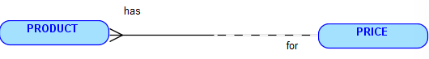
- Each SCHOOL may be attended by one or more STUDENTS. Each STUDENT must attend one and only one SCHOOL.

- Each EMPLOYEE must hold one and only one JOB. Each JOB may be held by one or more EMPLOYEEs.

- Each TOWN may be the birthplace of many PEOPLE. Each PERSON must be born in one and only one TOWN.


Exercise B: Are the following entities normalized? If not, make the necessary changes to correct it.
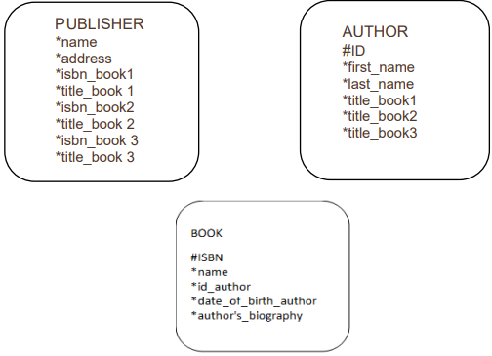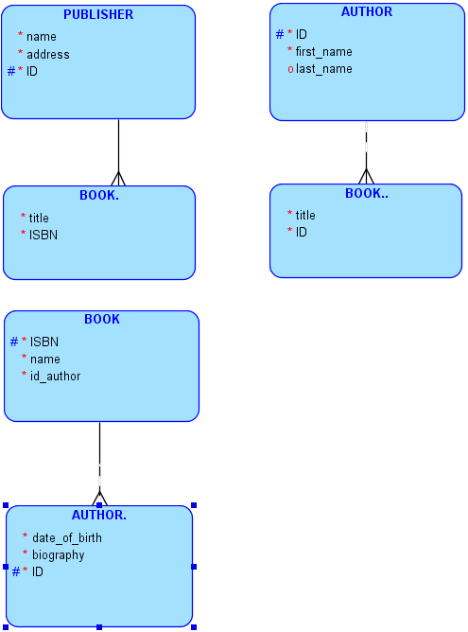
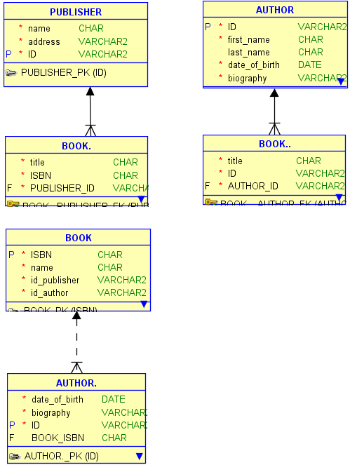
Exercise C: Resolve the M:M relationships
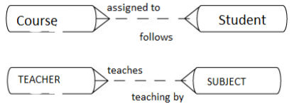
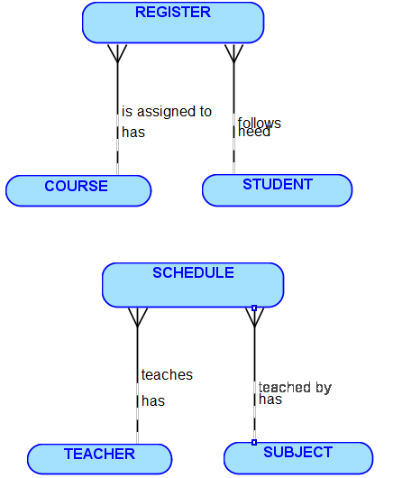

Exercise D:
1. Determine how exclusive relationships should be modeled in the following scenario.
An Event can be held at either a Private Home or a Public Space.
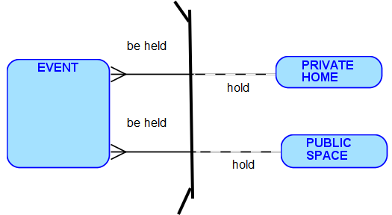
2. Develop a hierarchical structure to represent the following situation.
Each President can have one or more Directors. Each Director can have one or more Managers. Each Manager can have one or more Employees.
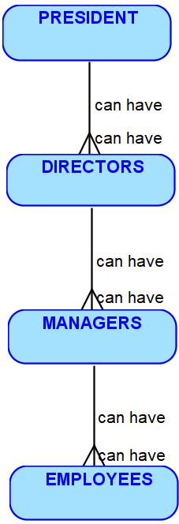

Exercise E: Using the following scenario
- Draw the conceptual model
Book, Authors, Publishers, Warehouses, Customers, Shopping carts, Billing Address
- Identify the possible Entities, their Attributes and the relationships between the entities from the given scenario.

3. Draw the ERD following diagramming convention.

- Draw the physical model (I didn’t manage to complet it becaus I got confused without the conceptual model, I din’t manage to download the app because of a bug on my computer)
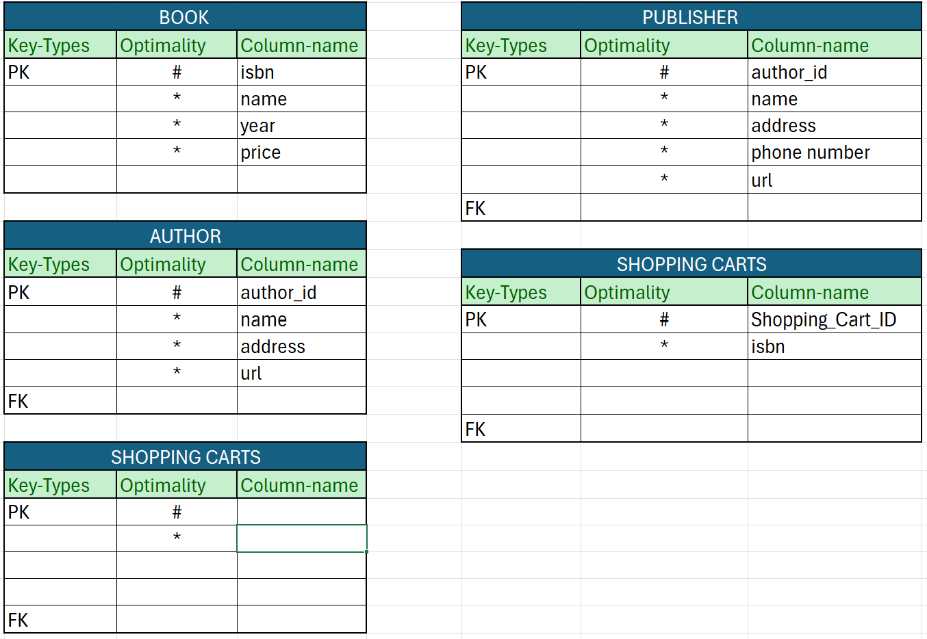
5. Write the sentences for each relationship, in both directions.
Each BOOK must be writen one and only one AUTHOR. Each AUTHOR must have writen one or more BOOK.
Each BOOK may be stocked in one or more WAREHOUSE. Each WAREHOUSE may have stocks of one or more BOOK.
Each COSTUMER may own one or more SHOPPING CARTS. Each SHOPPING CARTS may be owned by one and only one COSTUMER.
Each PUBLISHER may publish one or more BOOK. Each BOOK may be published by one or more PUBLISHER.
Each BOOK may be inside a SHOPPING CARTS. Each SHOPPING CARTS must contains one or more BOOK.
Each COSTUMER may have one or more BILLING ADRESS. Each BILLING ADRESS must be owned by one and only one COSTUMER.
6. Map the relationhips.
7. Draw the matrix diagram.
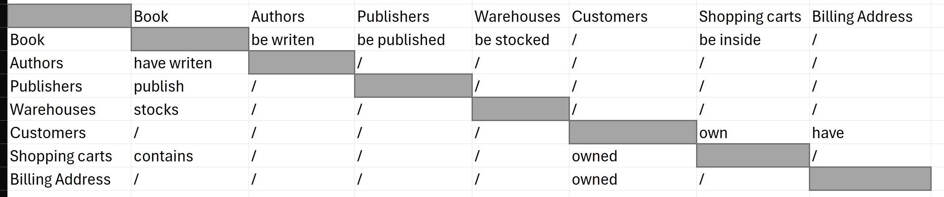
Book.com is an online store on the Internet where customers can browse the catalog and select products of interest. Every book has a title, isbn, year and price. The store also keeps the author and publisher for any book.For authors, the database keeps the name, address and the url of their homepage. For publishers, the database keeps the name, address, phone number and the url of their website. The store has several warehouses, each of which has a code, address and phone number. The warehouse stocks several books. A book may be stocked at multiple warehouses. The bookstore keeps the name, address, email-id, and phone number of its customers. A customer owns several shopping carts. A shopping cart is identified by a Shopping_Cart_ID and contains several books. More information will be needed to complete the transaction. Usually, the customer will be asked to fill or select a billing address, a shipping address, a shipping option, and payment information such as credit card number.

